Disability Information Scotland

Training Resources

A Guide to Easy Read

Easy Read Documents
Easy Read is about making written information easier to understand. Easy Read documents have short, simple sentences often with pictures.
Easy Read is also known as:
- making information easier
- easier to understand information
- simple words and pictures
- easy write
- easy info.
Easy Read documents are used to make information more accessible to people with learning disabilities. They can also be useful for people with other communication difficulties including:
- acquired brain injury
- dyslexia
- people with hearing impairment whose first language is British Sign Language (BSL)
- people who do not speak English as their first language
- people who find reading difficult
- people with cognitive impairments such as dementia.

The Equality Act
Public authorities have a duty to promote equality and eliminate discrimination. This may involve making sure that disabled people have equal access to information.
There are two kinds of Easy Read documents.

Group 1: for the general population
These include documents that will be used by a lot of people. They may be an easy version of a more complex document.
Example: an easy read version of an Act of Parliament
Or, the easy read version may be the only one produced.
Example: a voluntary organisation supporting adults with a learning disability decides to make all its documents in easy read

Group 2: personalised
These include documents written for one person or, a small group of people. For example, people who share the same house. The words will be about that person or group and the pictures may be photographs of people and places that they know.
Example: the kind of support that a person needs
Some types of information are so specific they are going to be of use to only a handful of people. Instead of spending money on an easy read version, maybe you could simply speak to these people over the phone or in person.
It is likely that it will be preferable to speak to people in person, possibly using easy read information to help the discussion.
Example: how to do a job
Easy Read documents will not meet the needs of everyone who has difficulties in reading and understanding written information.
Easy Read documents will:
- allow some people to access the information independently
- provide a useful tool for support workers when working with individuals or groups
- enable people to make their own choices.
Easy Read documents are just one way of helping people understand information. Other ways include:
- speaking to someone
- film (DVD or internet sites like YouTube)
- Audio recordings (CD, MP3).

Top Tips for Writing Easy Read Documents

Things to think about before you start
- Who the information is for
- What they need to know
- Why they need to know
- 80% of people with a learning disability have communication difficulties

Words
- Use short words
- Use simple words
- Avoid putting more than one idea in a sentence
- Stick to concrete ideas
- Try to use I, we, you
- Try to use the present tense
- Try not to use jargon or long, hard words
- If you must use a hard word, explain what it means

Numbers
- Write numbers in figures
- Use a clock to illustrate time

Length
- Write short sentences
- Keep your documents short
- Don’t miss anything important

Pictures
- Pictures should support the meaning of the words
- Pictures must be easy to understand
- Pictures can be drawings, photographs or other images
- Make pictures as big as possible
- Where possible use pictures that have a meaning for the person or group of people. For example, use pictures that are local.

Layout
- Use a large font size (at least 14 point)
- Use plenty of white space
- Use Ariel font
- Use one colour of print
- Use clear headings

Testing
- Once you have written your document read it out loud. Can you get rid of more words?
- Discuss the draft with a group of people who might use it. Make agreed changes and take it back to the group for agreement.

An example of EasyRead communication inviting someone for a doctors appointment can be seen in the following page. Note that simple images always appear to the left of short, simple paragraphs of text.
 | An appointment has been made for you with a doctor to have your test done
 | Your appointment is at 10.10am on Thursday 31st July
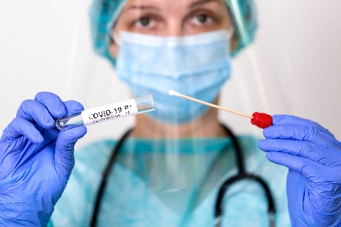 | During your appointment the doctor will take a swab from the back of your throat
 | The doctor will then send this sample away to be analyzed at a laboratory
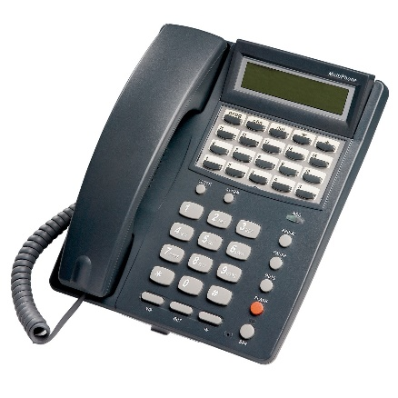 | The doctor will then call you within a week to tell you the results of your tests

Useful Publications

- Inspired Services Guides to Easy Read
Inspired Services | EasyRead Documents
- Producing Easy Read Documents Disability Equality Scotland Easy Read Service
- Guidelines on inclusive information by the Scottish Government Scottish government Inclusivity guidelines

Useful Organisations

Enable Scotland, Accessible information Unit
Tel: 0300 0200 101
Email: enabledirect@enable.org.uk
Website: www.enable.org.uk

FAIR, 95 Causewayside, Edinburgh EH9 1QG
Tel: 0131 662 1962
Email: fair@fairadvice.org.uk
Website: www.fairadvice.org.uk

FAIR DEAL, 355a Tormusk Road, Castlemilk, Glasgow G45 0HF
Tel: 0141 634 4996
Email: info@fair-deal.org
Website: www.fair-deal.org

Scottish Commission for Learning Disability
Suite 5.2
Stock Exchange Court
77 Nelson Mandela Place
Glasgow G2 1QY
Tel: 0141 248 3733
Email: admin@scld.co.uk
Website: www.scld.org.uk

This guide was produced to conform with the accessibility guidelines set out by SAIF (Scottish Accessible Information Forum)

Contact Us

Disability Information Scotland
Norton Park
57 Albion Road
Edinburgh
EH7 5QY
Call our helpline on 0300 323 9961
Monday - Friday 10:00am to 3:00pm
Text: 0798 436 7599
Email: info@disabilityscot.org.uk
www.disabilityscot.org.uk

FaceBook @DisabilityScot
Instagram @DisabilityScot
Twitter @DisabilityScot

