Disability Information Scotland

Training Resources

Producing Accessible PDF Documents From a Word Document

In this tutorial we are going to look at how to create an accessible PDF document from a Word file. The instructions below apply to Microsoft 365, Office 2021, Office 2019 and Office 2016. The screenshots are from Offcie 365 (June 2022).
- The first thing you should do after creating your document is to run the accessibility checker in Word to ensure your document is accessible before converting it to a PDF. To run the accessibility checker click on the Review tab and choose Check Accessibility. A menu system will appear on the right hand side of the screen advising you of any issues which you should rectify before going any further.
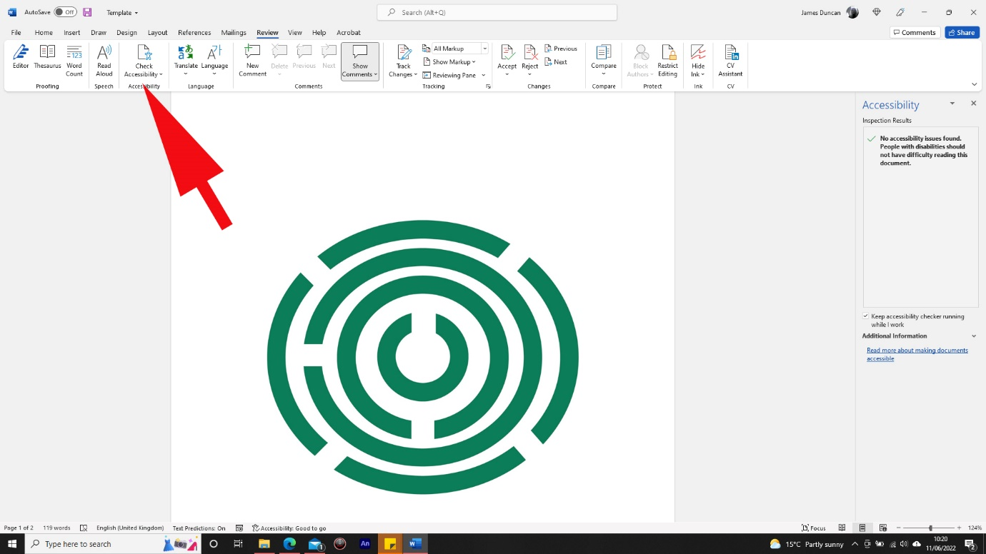

- Once you have ensured your document is fully accessible you can then begin the conversion to PDF process by clicking on the File menu then choosing Save As. Click Browse to select a location for your document and in the Save As dialogue box which appears click on Options.
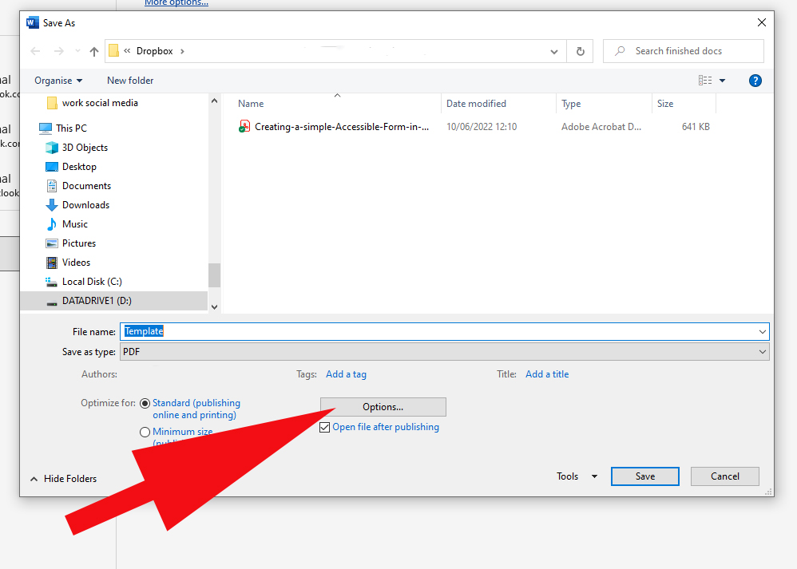

- You will then be presented with a dialogue box on which you should check the box labelled Document Structure Tags for Accessibility. This will add tags to your document which will allow people who use screen readers to be able to navigate and read documents which contain tables, hyperlinks and alternate text for images etc.
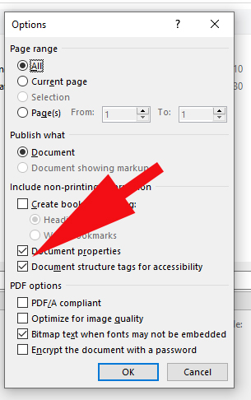
- To finish click on OK then Save. Your newly created PDF will be available in the location where it was saved.

This guide was produced to conform with the accessibility guidelines set out by SAIF (Scottish Accessible Information Forum)

Contact Us

Disability Information Scotland
168 Bath Street
Glasgow G2 4TP

Call our helpline on 0300 323 9961
Monday - Friday 10:00am to 4:00pm

Text: 0778 620 0707

Email: info@disabilityscot.org.uk

www.disabilityscot.org.uk

FaceBook @DisabilityScot
Instagram @DisabilityScot
Twitter @DisabilityScot

