Disability Information Scotland

Training Resources

How to Use Styles For Accessibility Using Word 365
Introduction

This Step-by-step guide will explain how to set up and use Styles in Microsoft Word to make the document more accessible to people using screen readers. It was written in and includes screenshots from the June 2022 version of Word (Windows Version) but these instructions also apply to all versions of Word (Windows Versions) going back to Word 2013.

Explanation of Styles

Styles are a set of formatting options you can apply to the text in your document. They have names like Heading 1, Heading 2, Normal and Intense and each one comes with its own formatting styles which you can change if required. You can see the list of styles your version of Word can use in the Styles section of the Home Tab.
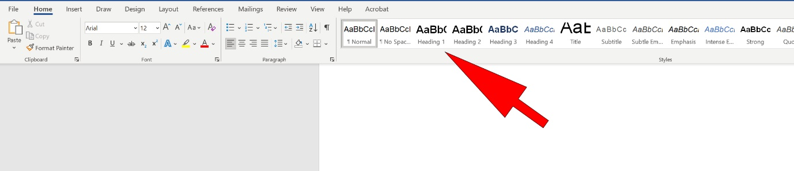
The Normal Style is used for all the regular non-heading text in your document such as this sentence.
The Headings styles are, as the name implies, for formatting headings in your document and are important for accessibility as they are what screen readers use to separate a document into its different parts and navigate through it. For example if you had a document which explained how to write a CV you might split it up in the following way with the following section headings:

How to Write a CV (This would be the main heading and you would apply the style Heading 1 to it (see instructions on how to do this later in document)
Adding Your Name and Address (This would be the first thing you would do when writing a CV and because it is a subheading the main heading you would apply the Heading 2 style to it). Your instructions would be written below this in Normal Style.

Writing a Personal Statement (This would be the next section heading and would also have the Heading 2 style applied to it as it is also a subheading of the main heading). Your instructions would be written below this in Normal Style.
Your Previous Employment Details (This would be next subheading of the main heading and you would also apply the Heading 2 style to it). Your instructions would be written below this in Normal Style.
Describing the Tasks in Your Previous Jobs (This could be a subheading of the previous employment advice so you would apply the Heading 3 style to it). Your instructions would be written below this in Normal Style.
Etc etc…

So you can see in this simple example above how you would apply heading styles to the individual section headings. If you were sighted you would be able to either read the whole document or scan through the document until you came to the heading you needed to find out about and then read the description below it.
If you were using a screen reader, however, you would need it to be able to identify where it was in the document and where it needed to go to read through the document in the way you choose. You may want to read it straight from start to finish or read it by skipping paragraphs, jumping to specific sections or reading sections again etc.
It is by assigning Heading styles to a documents different sections that it is able to do all this. Someone using a screen reader will very easily be able to make the screen reader jump backwards and forwards from section to section based on the style you have applied to each sections heading.

Applying a Heading Style to a Section Heading
To apply a heading style to section heading select your text then click on your chosen Style (Heading 1, 2 or 3) on the Home Tab. Remember to have a logical progression through your document or your document or it will not be easily navigable by anyone using a screen reader.
- Heading 1
  - Heading 2
  - Heading 2
    - Heading 3

Modifying your Heading Styles
You may want to change the look of your heading or normal styles from the default look Microsoft comes with. For example if you wanted to change its font or font size or whether it was bold etc right click on the Style in the Styles section of the Home Tab and choose Modify Style.
In this dialogue box you will be able to change the font, its size, style and alignment amongst other changes. You can also set these changes as for the current document only or for all the new documents based on the template this document uses. A description of Word templates and how to use them for accessibility appears in our training document Setting Up and Using Templates in Word for Accessibility.
When you modify a particular style it will modify all the text you have applied that style to in your document.
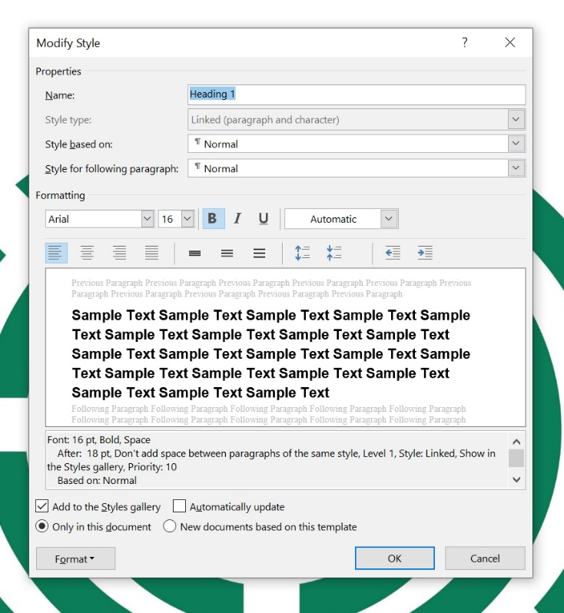

SAIF (Scottish Accessible Information Forum) recommend the following settings for good accessibility in headings and body text.

- Normal Style for non-heading text - Size 14 Regular, Arial

- Heading 1 - Size 18 Bold Arial, 3 points before, 12 points after, Arial

- Heading 2 - Size 16 Bold Arial, 3 points before, 12 points after

- Heading 3 - Size 14 Bold Arial, 3 points before, 12 points after

- Header and Footer - Size 12 Regular Arial

Checking Your Document for Accessibility
When you have finished your document you should check it for accessibility using Words built-in accessibility checker. To do this Click on the Review Tab and choose Check Accessibility. A box will appear at the right side of your screen advising you of any issues your document might have in terms of accessibility and also advice on how to fix them.

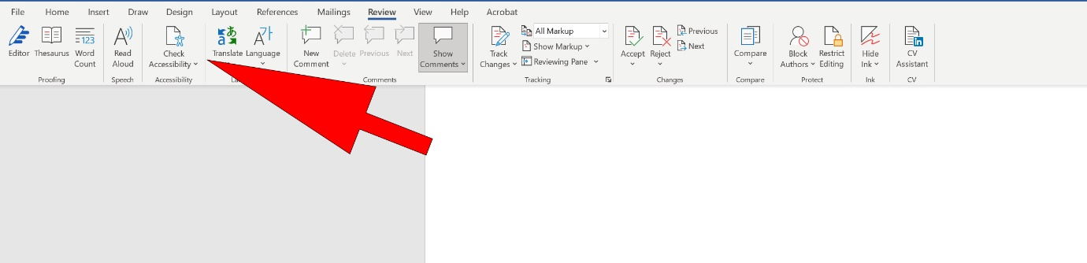

Contact
Disability Information Scotland
168 Bath Street
Glasgow G2 4TP

Call our helpline on 0300 323 9961
Monday - Friday 10:00am to 4:00pm

Text: 0778 620 0707

Email: info@disabilityscot.org.uk

www.disabilityscot.org.uk

FaceBook @DisabilityScot
Instagram @DisabilityScot
Twitter @DisabilityScot

This guide was produced to conform with the accessibility guidelines set out by SAIF (Scottish Accessible Information Forum)

