Disability Information Scotland

Training Resources

Creating an Accessible Template in Word

Introduction

The default template in your Word software is called Normal.dot and is the blank page which appears when you open Microsoft Word and create a new blank document.

Although it starts off as an empty page it is set up to use a number of predetermined settings such as what the default font will be and the default paragraph spacing etc as well as how all the individual styles such as Heading 1 and Heading 2 will look like when you apply them to text.

For example it might be set up to format the Heading 1 style as Arial, 14pt, Bold and with 6pt spacing before and 12pt spacing after it.

Heading 2 could be set to be formatted as Arial, 12pt, Bold and with 3pt spacing before and 12pt spacing after.

This formatting of text and spacing is important as it can have a big impact on the accessibility of your document. Fonts which are too small or which use a ‘handwriting’ style can be difficult for people with visual impairments to read. As well as this poorly formatted or unused Heading Styles can leave your document difficult for someone with a screen reader to navigate. For a more detailed description of Headings and why they are important for accessibility please see our document ‘How to Use Styles For Accessibility Using Office 365’ available below as a Word document

How to Use Styles for Accessibility Word Document

or as a PDF here:

How to Use Styles for Accessibility PDF Document

Note that you should be able to edit the default template if you have a standalone computer. If you have a networked work computer you may need to speak to your IT Support people to make any changes to the default template.

Formatting Your Default Word Template for Accessibility
The examples in this document were made in Word 365 (June 2022) but the instructions should be the same for all Word versions going back to Word 2013.

Setting the Default Font in Your Document
The default font for your document is referred to as ‘Normal’ in the Styles Menu and is the font which will be used for anything which is not specifically given another style or edited in appearance by yourself. The text you are reading now is ‘Normal’ Font and the Heading above it is formatted as Heading 2.
To set the default font for your document do the following:

- On the Home Tab click on the Dialogue Box Launcher in the Fonts section. It’s the small square box at the bottom right of the Font section in your Home Tab that you can see this in the image below.
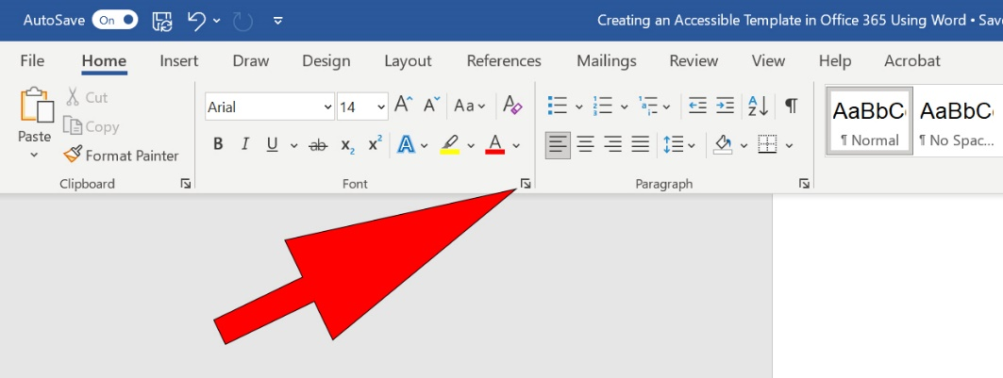

- This will open up the Font Dialogue Box where you can set your default font, its size and its style. A full guide to the recommended accessibility settings is at the end of this document. When you have chosen these click on Set as Default.

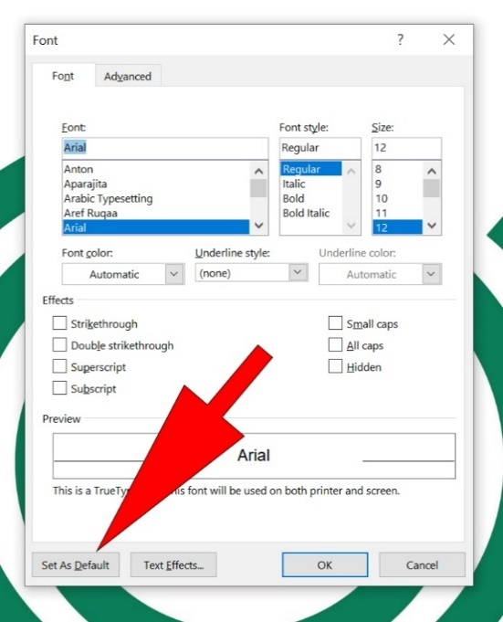

- This will open up a dialogue box where you will be asked to choose whether to apply these settings to this document only or all documents based on the Normal Template. Choose All documents based on the Normal Template and click OK (See Saving Your Document section at the end of this document for more options)
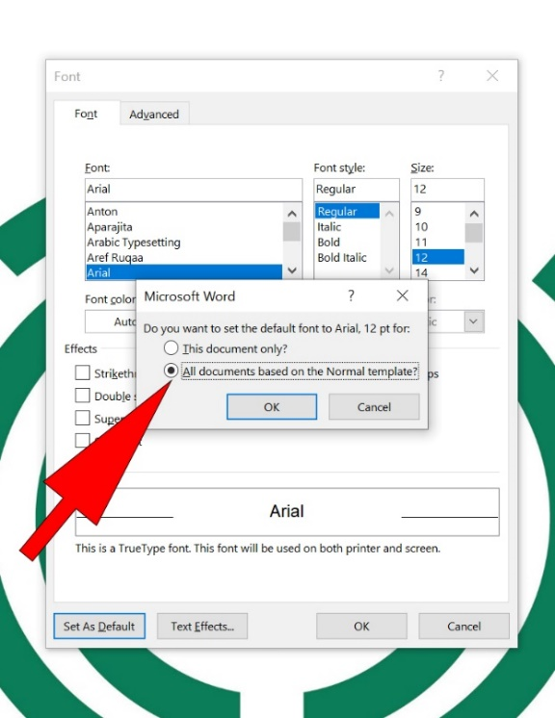

Setting the Line and Paragraph Spacing
Setting the line and paragraph spacing is important for accessibility as people with visual impairments may have difficulty tracking lines of text which are too close together.
To set your line and paragraph spacing click on the Paragraph Settings button which is a small square at the bottom right of the paragraph section on the Home Tab. You can see it in the image below.
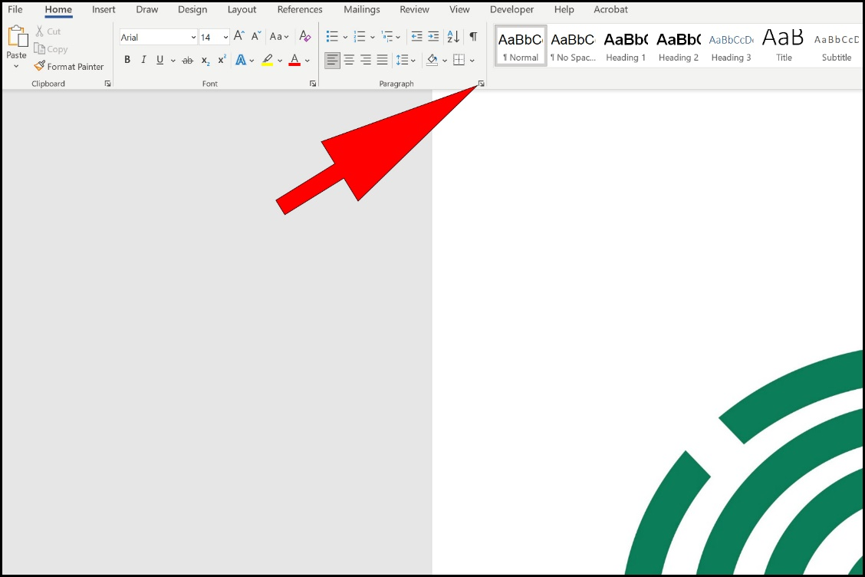

This will open up the Paragraph Settings Dialogue box where you can change the default line spacing, paragraph spacing. Alignment and other options.
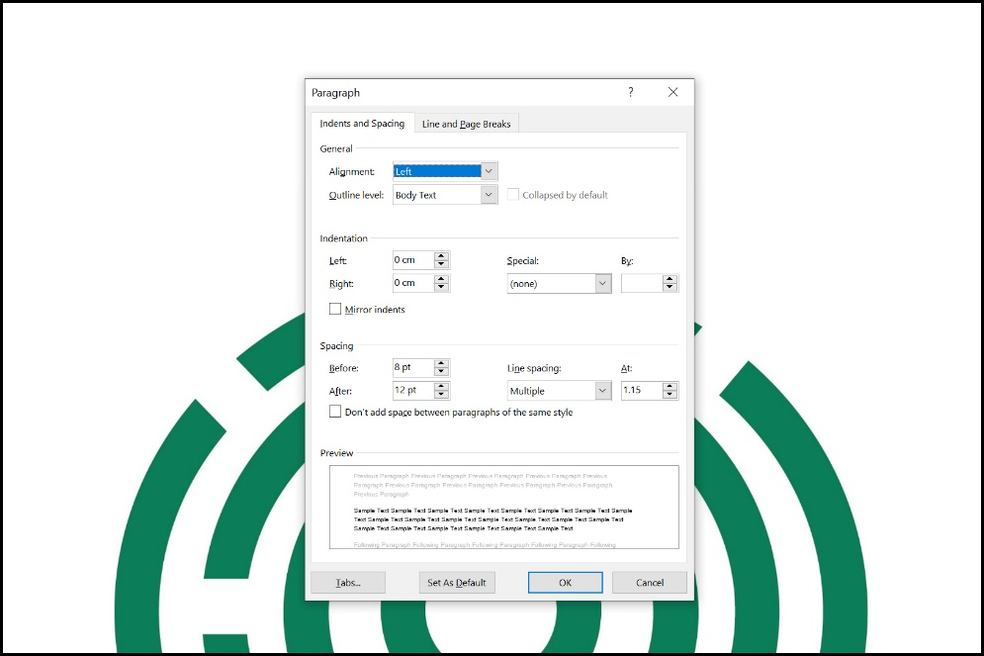

When you have made your changes click on Set as Default. This will bring up a dialogue box allowing you to select either to save these changes just to your current document or save them to all documents based on the Normal Template. Choose All Documents Based on the Normal Template and click OK (See Saving Your Document section at the end of this document for more options)
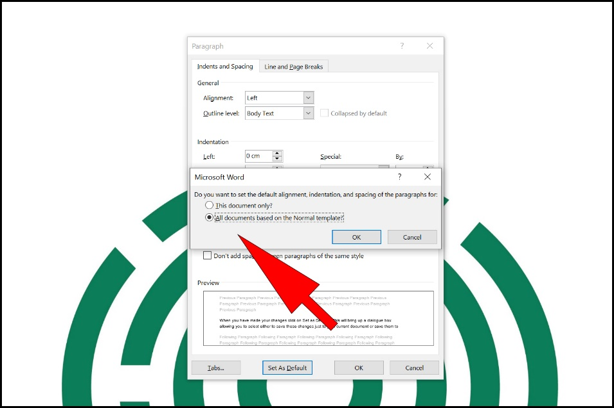

Use of colour
These recommendations are based on using a black typeface. However, you may wish to introduce colour into your template, for example in Headings and Bullet Points to make them stand out. This will not affect the electronic accessibility of a document but may affect its visual accessibility. You need to check that there is good contrast between text and background:
· on screen
· printed in colour and greyscale
· photocopied in colour and black and white

Style Recommendations
SAIF (Scottish Accessible Information Forum) recommends the following settings for accessibility:

Body Text (Normal Style)
- Arial - Size 14 Regular
- Paragraph Spacing - 12 points after paragraph. Setting the default paragraph spacing means that you will not need to use the Return Key to create space between paragraphs.
- Line Spacing – Multiple 1.15
- Alignment - Left

Heading Styles
- Heading 1 - Size 18 Bold, 3 points before, 12 points after
- Heading 2 - Size 16 Bold, 3 points before, 12 points after
- Heading 3 - Size 14 Bold, 3 points before, 12 points after
- Header and Footer Text – Arial - Size 12 Regular

Saving your document
If you go through the procedures shown above you will be editing the default ‘Normal’ template that Word will open when you click to create a new blank document. You can, however, choose not to edit the default template but to make a completely new template which you can open up when you start Word or at any time by clicking the File Menu and clicking New before choosing your template from the list available.
To save your own template go through the steps above and then instead of clicking All Documents Based on This Template when you get to the saving stage choose This Document Only and click OK. When you have finished making your edits click on File then Save A Copy then choose to save as a Word Template
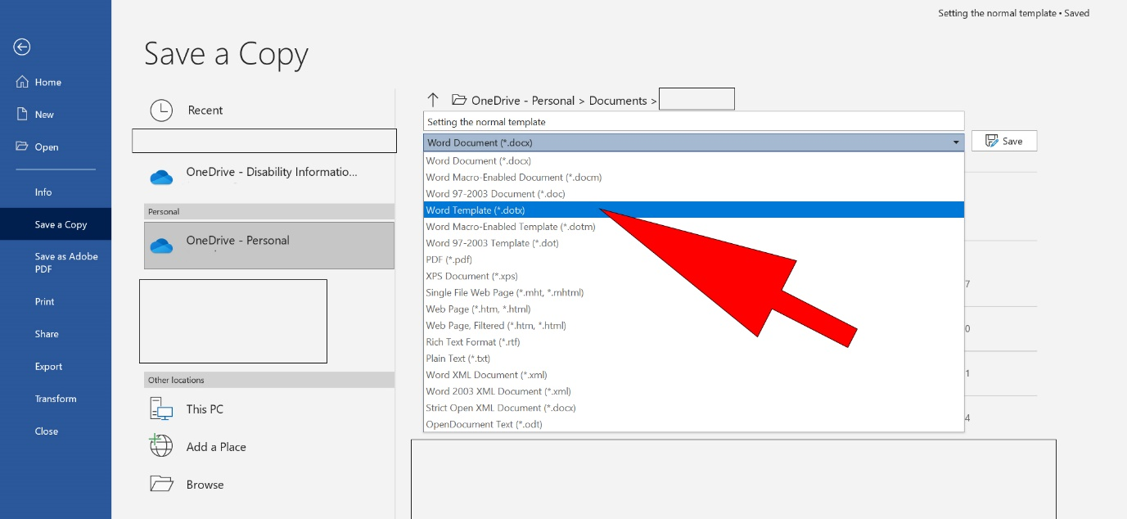

This guide was produced to conform with the accessibility guidelines set out by SAIF (Scottish Accessible Information Forum)

Contact Us

Disability Information Scotland
168 Bath Street
Glasgow G2 4TP

Call our helpline on 0300 323 9961
Monday - Friday 10:00am to 4:00pm

Text: 0778 620 0707

Email: info@disabilityscot.org.uk

www.disabilityscot.org.uk

FaceBook @DisabilityScot
Instagram @DisabilityScot
Twitter @DisabilityScot

