Disability Information Scotland

Training Resources

Creating a Simple Accessible Form in Office 365
Using Word
This tutorial will demonstrate how to add text boxes and other interactive elements to an accessible form in Word 365
We can see an example of a simple form below where the end user is asked to enter a number of items of information, choose whether to be added to a mailing list and choose information from a drop down list.

Name
Click or tap here to enter text.
Email address
Click or tap here to enter text.
Phone Number
Click or tap here to enter text.
Click to be added to our mailing list?
☐
Date of Birth
Click or tap to enter a date.
How did you hear about us?
Choose an item.

Displaying the Developer Tab
Firstly we are going to use the Developer Tab in Word 365 to insert the form items we need. The Developer Tab may not be visible in your current Word setup so if your menu system does not look like the image below then you will have to make the Developer Tab visible.
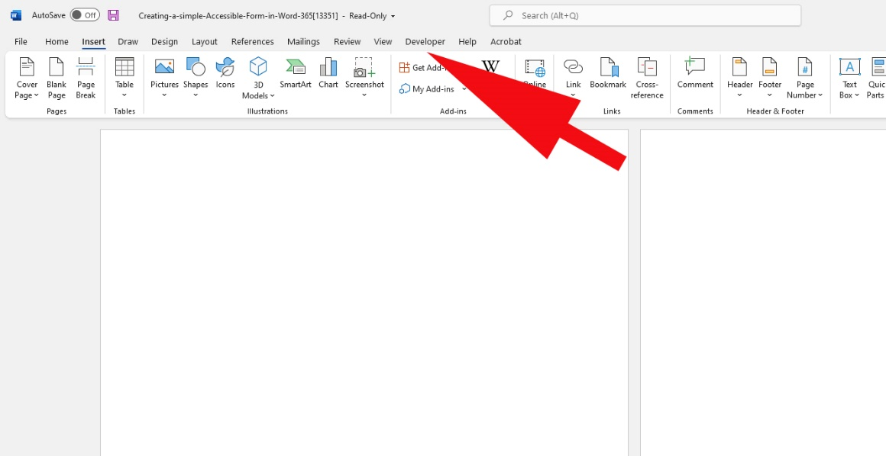

To make the Developer Tab visible click on File – Options. This will open up your options box where you select Customize Ribbon from the menu on the left then scroll down the right hand side scroll box and check the Developer box
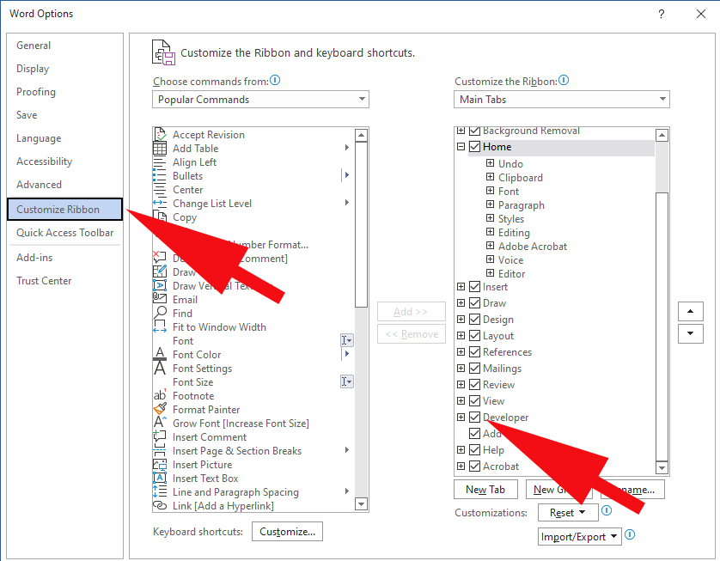

Adding a Text Box Content Control
We will start with the Name form box we can see in the example above. Type ‘Name’ to describe the information required. Now place the cursor where you want your check box to go then click on the Developer Tab and choose Plain Text Content Control to place a text box on our page.
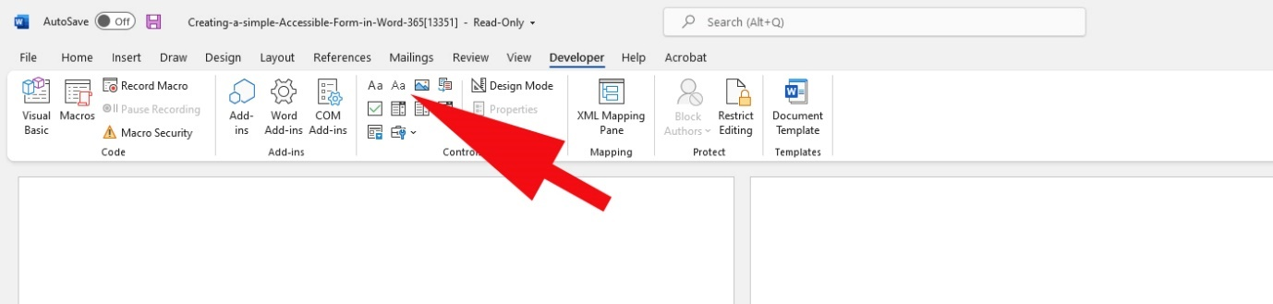
A text bow will be placed on the page with the default text ‘Click here to enter text’
So that a screen reader can describe this text box properly we are going to give this text box a title by clicking on it and then choosing Properties from the Developer Tab
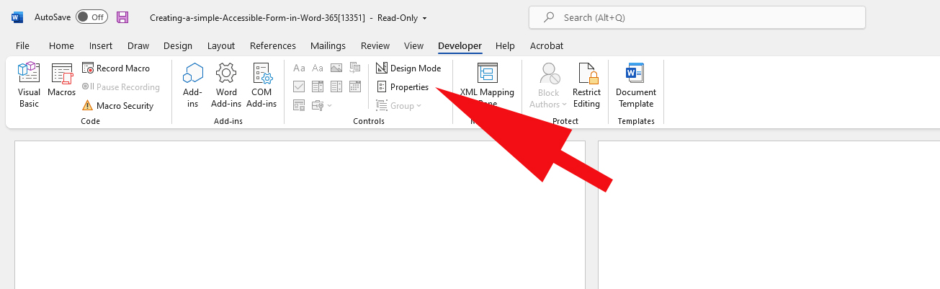
This will open up the Content Control Properties box where you can enter a descriptive title for a screen reader to read out to the end user. Click OK

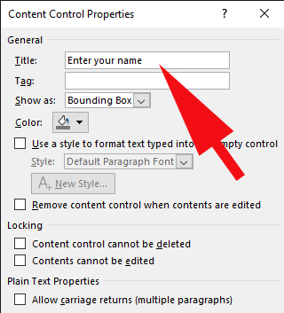
Repeat this process for all the other text boxes you require.

Adding a Check Box
To add a check box firstly type in a description of what information you want the check box to provide. In the case above it is asking the end user to click if they wish to be added to the mailing list.
Now place the cursor where you want your check box to go then click on the Developer Tab and choose Text Box Content Control.
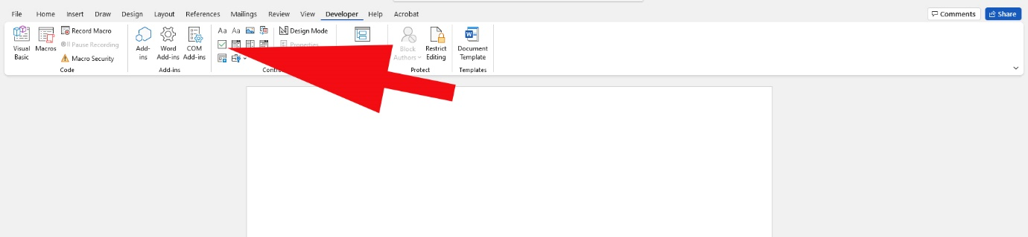
Click on this check box and choose Properties in the Developer Tab. In the dialogue box which appears give the check box a Title.

Adding a Date Entry Box
To add a Date Entry box firstly enter some text to describe what information you would like the end user to enter. In the case above we are asking the user to enter their date of birth.
Now place the cursor where you want your check box to go then click on the Developer Tab and choose Date Picker Content Control
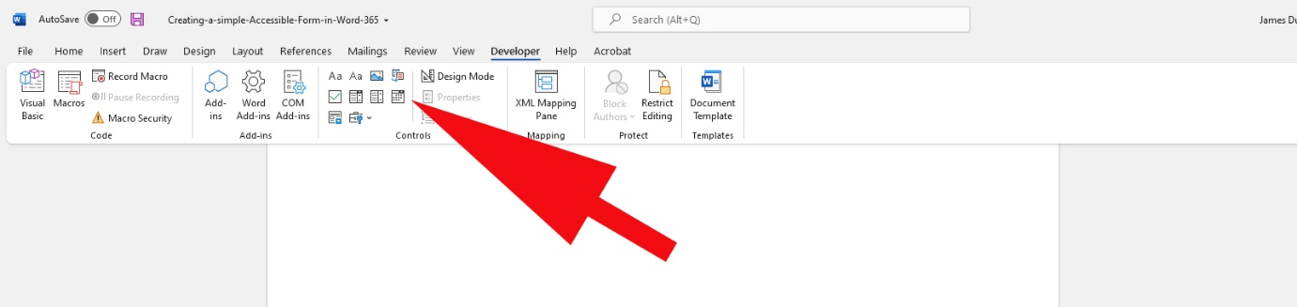
Now click the Date Picker Control on your page and then choose Properties from the Developer Tab. Here you will give the control a title and also be able to choose what format the date should appear in.
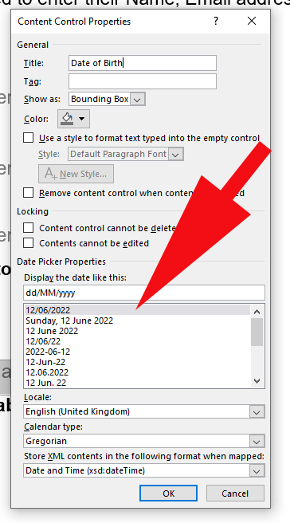

Adding a Drop Down List Box
To add a drop down list box to your form where you will give the end user a predetermined list of items to choose from firstly type a description for your box. In the form above we have asked the end user to choose from list to let us know where they heard about us.
Now place the cursor where you want your check box to go then click on the Developer Tab and choose Drop Down List Content Control.
Click on the Drop Down list box on your page and choose Properties from the Developer Tab. Here you can give the box a title and also click on Add on this tab to add items to your list individually.
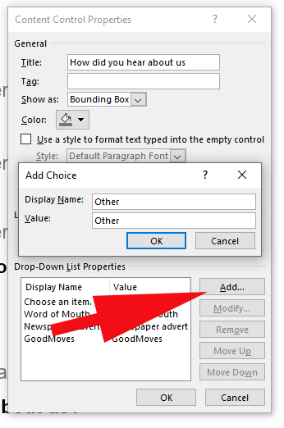

Last Steps

Checking your Document for Accessibility
Word 365 has a built in facility to check your document for accessibility issues and giving advice where appropriate to fix any issues.
To use the Accessibility Checker click on the Review Tab and choose Check Accessibility. This will open up a sidebar where any issues in the documents accessibility will be flagged and suggestions given.
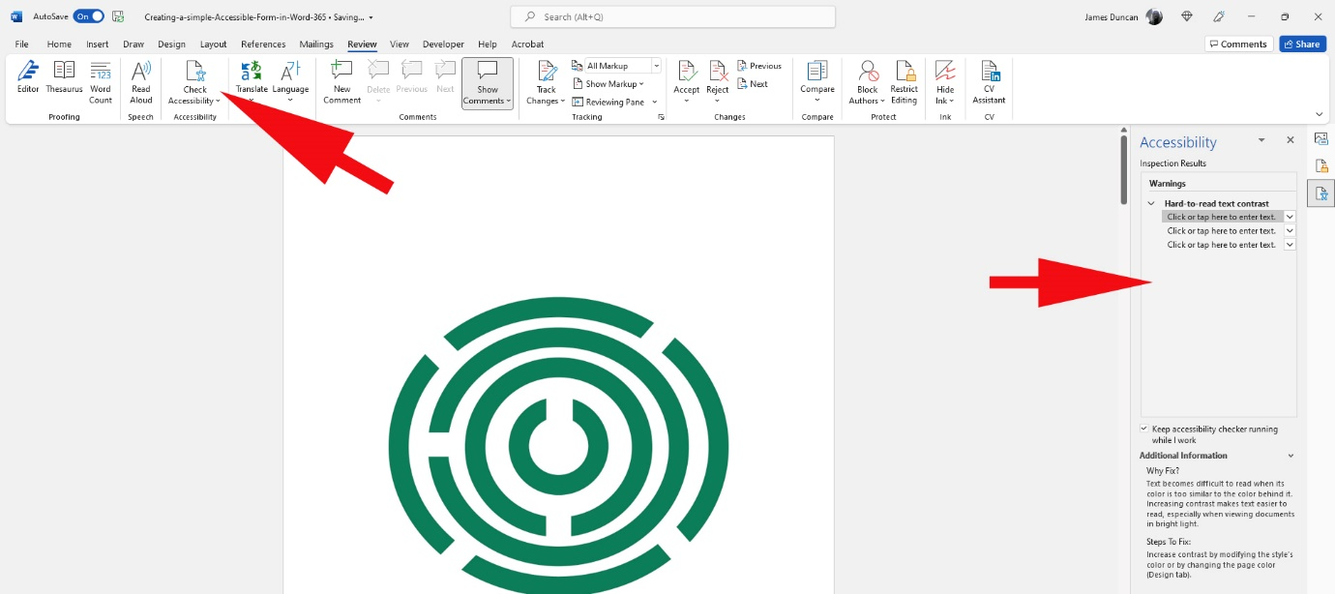

Protecting Your Form
When you distribute your form you may want to make sure that only the form elements on the page can be edited by the end user and not the rest of the text or images in the document. To do this click on the Developer Tab and then choose Restrict Editing. From the drop down list under Editing Restrictions choose Filling in Forms and this will lock all the text and images in your document apart from the form elements you would like filled in by the end user. You can also choose to password protect the editing of your document at this point.

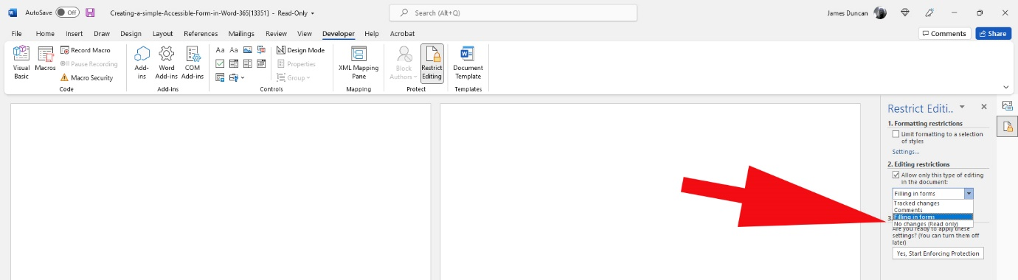
This guide was produced to conform with the accessibility guidelines set out by SAIF (Scottish Accessible Information Forum)

Contact Us

Disability Information Scotland
168 Bath Street
Glasgow G2 4TP

Call our helpline on 0300 323 9961
Monday - Friday 10:00am to 4:00pm

Text: 0778 620 0707

Email: info@disabilityscot.org.uk

www.disabilityscot.org.uk

FaceBook @DisabilityScot
Instagram @DisabilityScot
Twitter @DisabilityScot

