Disability Information Scotland

Training Resources

Checking Your PDF Document for Accessibility
This document details how to check your PDF documents for accessibility in Adobe Acrobat (June 2022 version)

Starting the Accessibility Checker
Open up Acrobat Pro DC and have a look at the toolbar on the right hand side. You are looking for the Action Wizard button. If you don’t have this button on your toolbar click on the More Tools button at the bottom of your menu list.
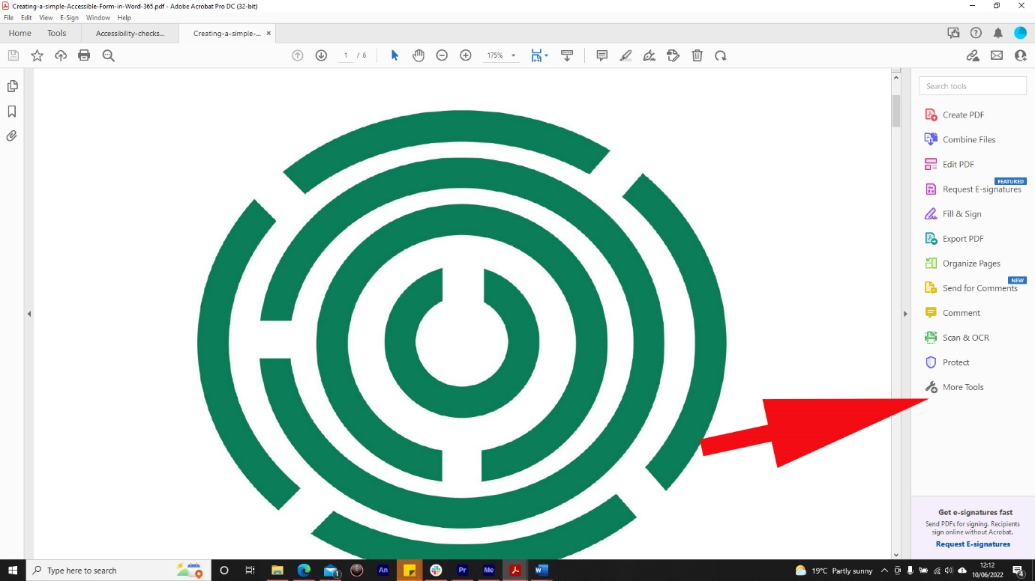

You will then be taken to a page which will allow you to add menu items to your toolbar. Find Action Wizard and click Add
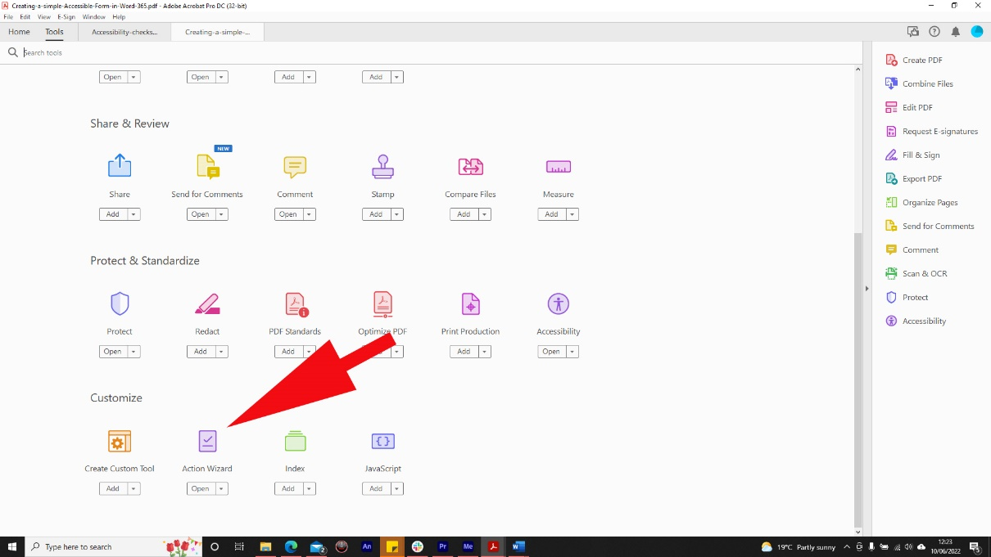
The Action Wizard will then be added to your toolbar. Click on it and the toolbar will change to the Action Wizard toolbar. Click on Make Accessible.
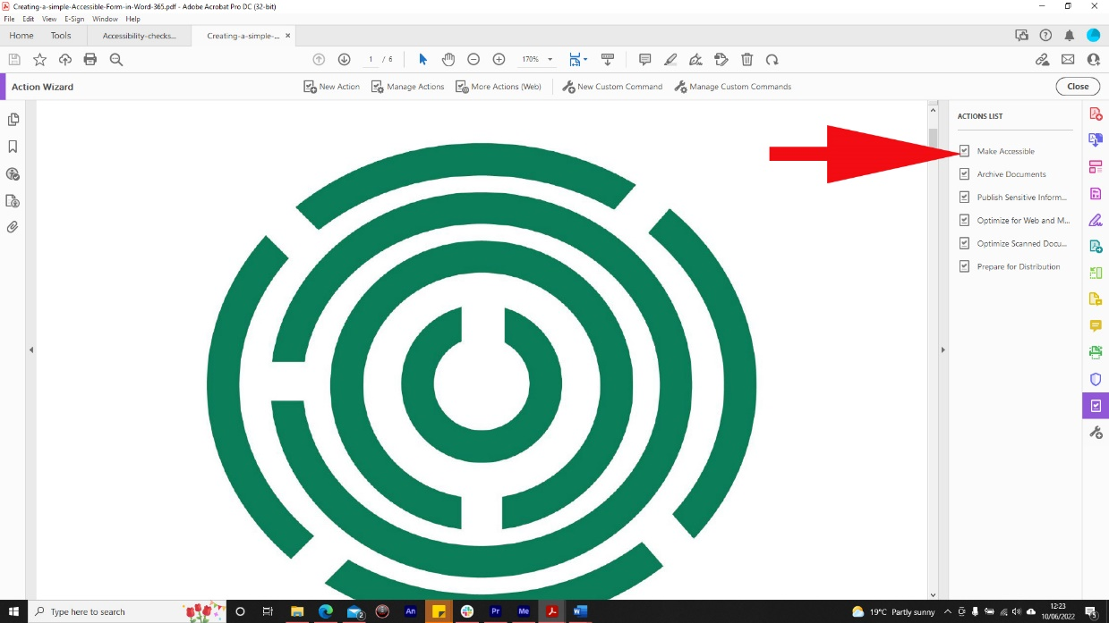

The toolbar will change to the Make Accessible toolbar and you will be presented with a list of checks you should consider before carrying out the accessibility check.
These may be different for every document but as an example in this document I was asked to create a title for my document. This could either be the title I had already given it when it was saved or it could be a new title. I would either click on OK to use the title already given or uncheck the Leave As Is box it the Title section to enter a different document title.
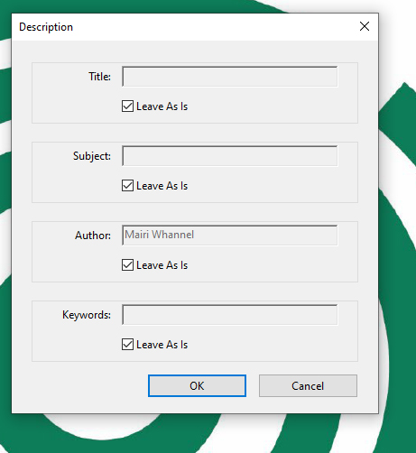

I was also asked to provide alternative text for an image so that it could be described by a screen reader
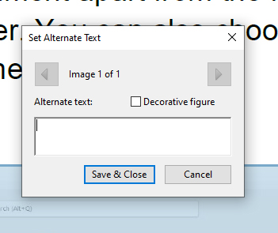
When all the checks were completed I was able to start the accessibility check by clicking the Start Checking button.
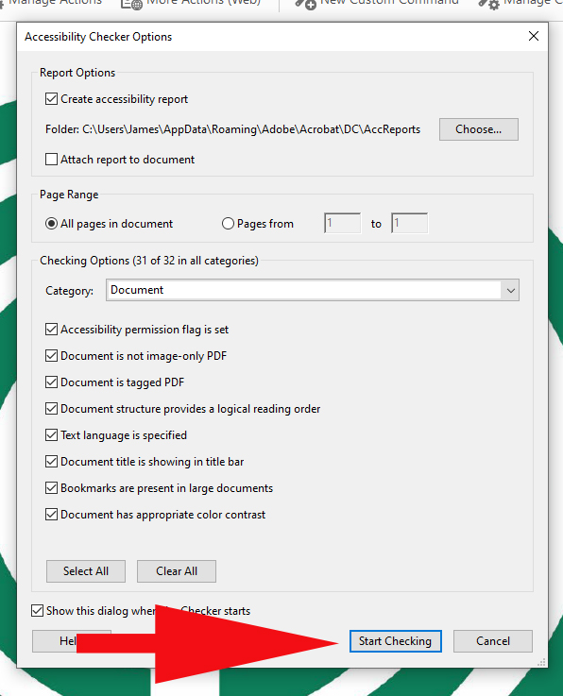
The document will be checked for any accessibility issues and any checks that have been completed along with their result (Passed or failed) will appear on the left hand side of the screen.
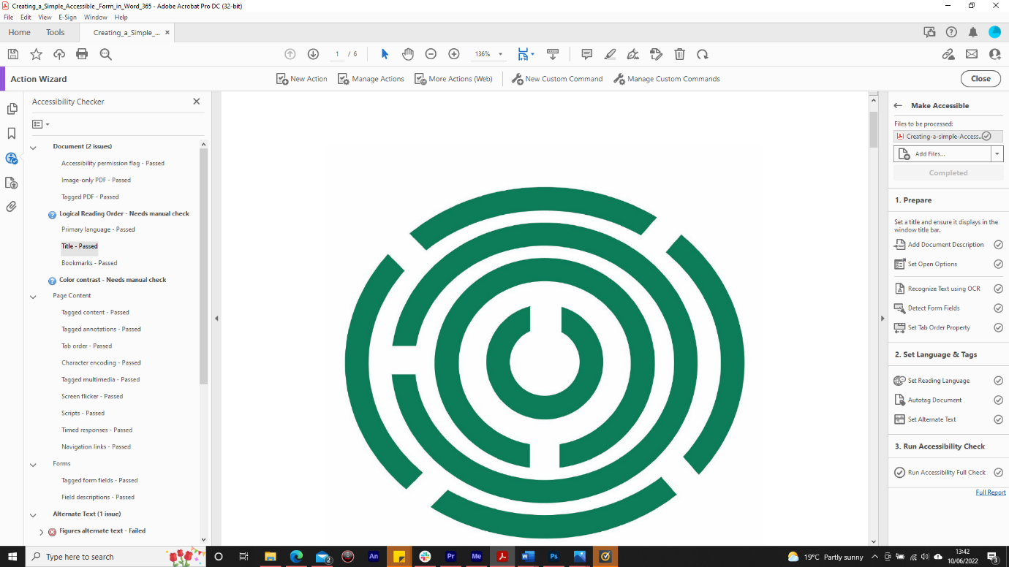
In this case all the checks that were carried out passed apart from document title as I had deliberately not changed this when it was suggested earlier on so that the error would be thrown up. It was also suggested that I check the contrast between text and an area of my screen as it was very low and would make it difficult for someone with a visual impairment to read. I was also asked to check the logical reading order to make sure my document read logically and would do so for someone with a screen reader. These last two suggestions need to be manual checks made by myself as the accessibility checker is not able to tell if a document makes sense or if the contrast between two parts of a page was indeed too low for a visually impaired person to be able to read.

To fix any issues click on the issue in the list and then click on the button and choose fix. You will then be guided through the process of fixing any issues. You can also click on the question mark beside any failed test or suggestion and you will be taken to Adobes website for a fuller explanation of your results.
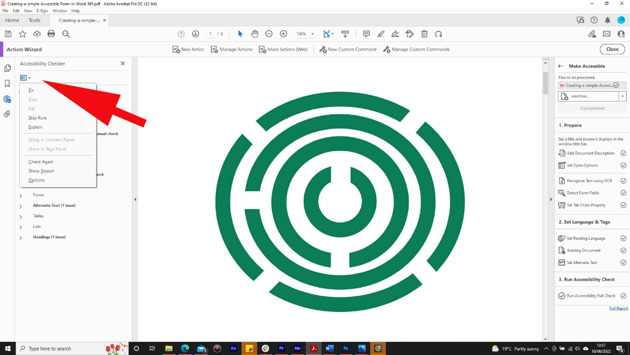

This guide was produced to conform with the accessibility guidelines set out by SAIF (Scottish Accessible Information Forum)

Contact Us

Disability Information Scotland
168 Bath Street
Glasgow G2 4TP

Call our helpline on 0300 323 9961
Monday - Friday 10:00am to 4:00pm

Text: 0778 620 0707

Email: info@disabilityscot.org.uk

www.disabilityscot.org.uk

FaceBook @DisabilityScot
Instagram @DisabilityScot
Twitter @DisabilityScot

